**KAREN G. HERNANDEZ BSIT – BA – 3201**

**LABORATORY ACTIVITY-DATA WAREHOUSING**

**MANUFACTURING BUSINESS**

**Business Questions**

1. What is the average cost per unit for each product category, considering the quantity produced and the total cost incurred**.**
2. Which top 10 products are the most profitable for the business, considering both production costs and sales revenue?
3. Which brand has the highest total quantity produced and what is the total cost of production for each brand?

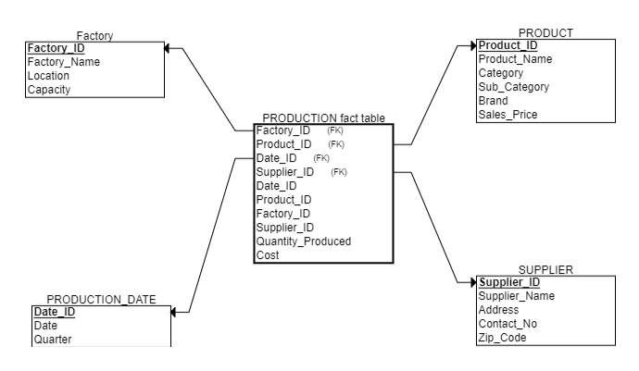**DIMENSIONAL MODELING**

**TABLES WITH SAMPLE RECORDS**

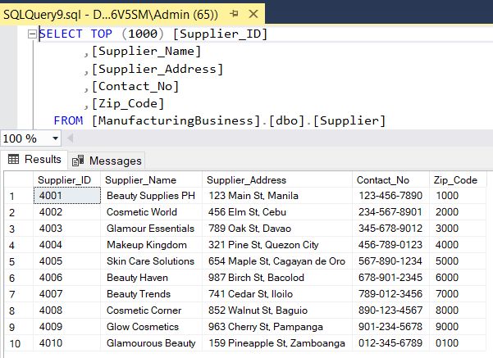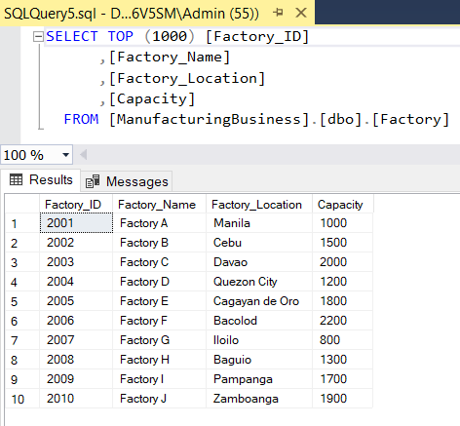

**Supplier**

**Factory**

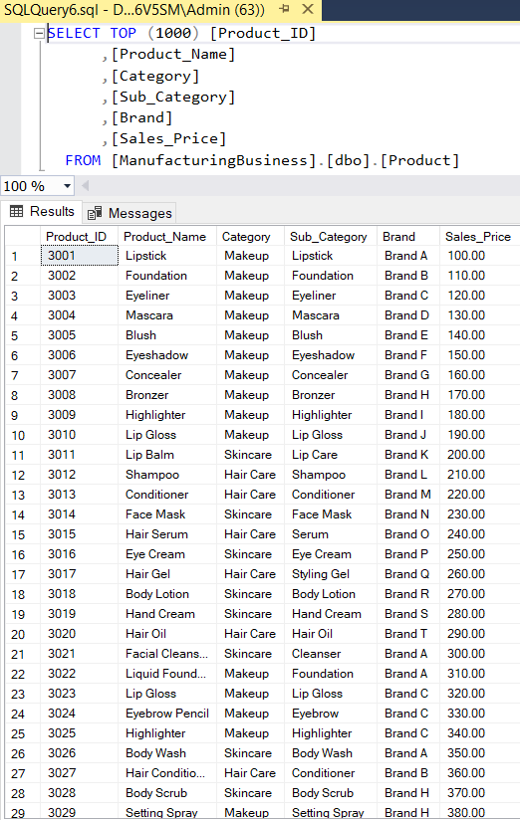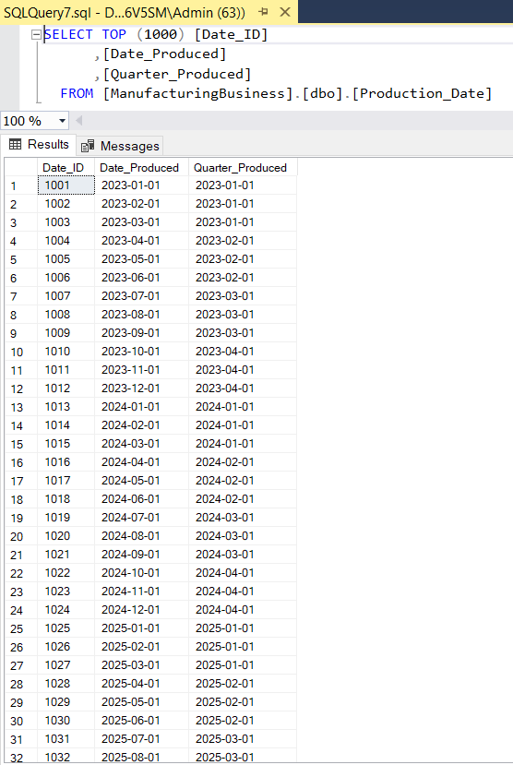

**Product**

**Production_Date**

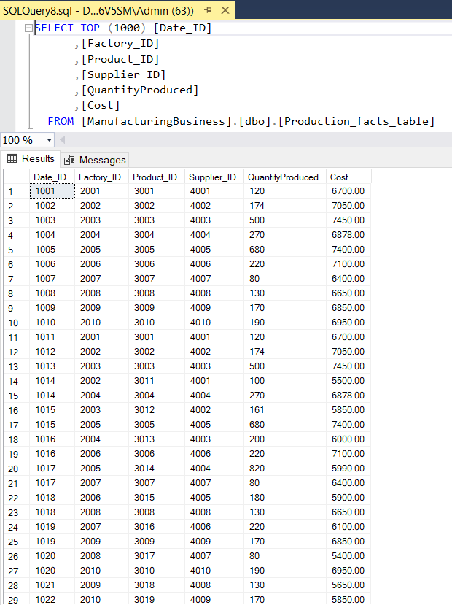

**Product_Facts_Table**

**SQL QUERIES**

**QUESTION 1:**

SELECT

p.Category,

SUM(pf.Cost) / SUM(pf.QuantityProduced) AS AvgCostPerUnit

FROM

[ManufacturingBusiness].[dbo].[Product] p

JOIN [ManufacturingBusiness].[dbo].[Production_facts_table] pf ON p.Product_ID = pf.Product_ID

GROUP BY

p.Category

ORDER BY

AvgCostPerUnit DESC;

**RESULT:**

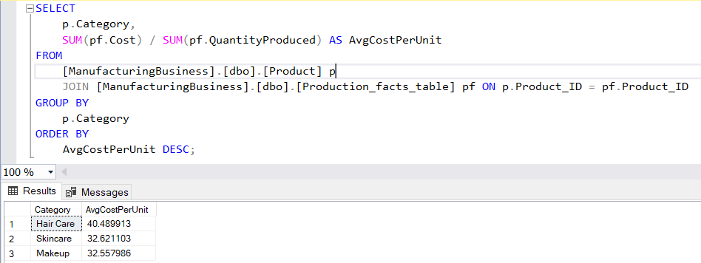

**QUESTION 2:**

WITH ProfitableProducts AS (

SELECT

pf.Product_ID,

p.Product_Name,

SUM(pf.Cost) AS TotalCost,

SUM(pf.QuantityProduced) AS TotalQuantity,

SUM(pf.QuantityProduced * p.Sales_Price) AS TotalSalesRevenue,

SUM(pf.QuantityProduced * p.Sales_Price) - SUM(pf.Cost) AS Profit

FROM

[ManufacturingBusiness].[dbo].[Product] p

JOIN [ManufacturingBusiness].[dbo].[Production_facts_table] pf ON p.Product_ID = pf.Product_ID

GROUP BY

pf.Product_ID, p.Product_Name

)

SELECT TOP 10

Product_Name,

TotalCost,

TotalQuantity,

TotalSalesRevenue,

Profit

FROM

ProfitableProducts

ORDER BY

Profit DESC;

**RESULT:**

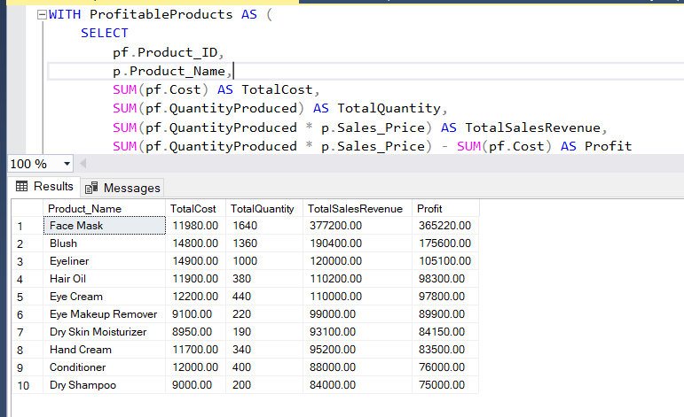

**QUESTION 3:**

SELECT

p.Brand,

SUM(pf.QuantityProduced) AS TotalQuantityProduced,

SUM(pf.Cost) AS TotalCost

FROM

[ManufacturingBusiness].[dbo].[Product] p

JOIN

[ManufacturingBusiness].[dbo].[Production_facts_table] pf ON p.Product_ID = pf.Product_ID

GROUP BY

p.Brand

ORDER BY

TotalQuantityProduced DESC;

**RESULT:**

